Annex A to: Ref.: SDFDS/A/001

Dated: 14 April 2025

*****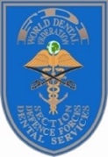*

**ABSTRACT FORM**

Section Defence Forces Dental Services Annual Meeting 2025

Xi’an, China 05-08 September 2025

Kindly submit to **sdfd.services@gmail.com** and cc to **AFMUSDFDS@163.com**

before **30 June 2025**

|  |  |
| --- | --- |
| **PRESENTATION TITLE** |  |
| **PRESENTER(S)** |  |
| **COUNTRY** |  |
| **ORGANISATION** |  |
| **ABSTRACT** |  |
| **BRIEF BIOGRAPHY OF PRESENTER** |  |